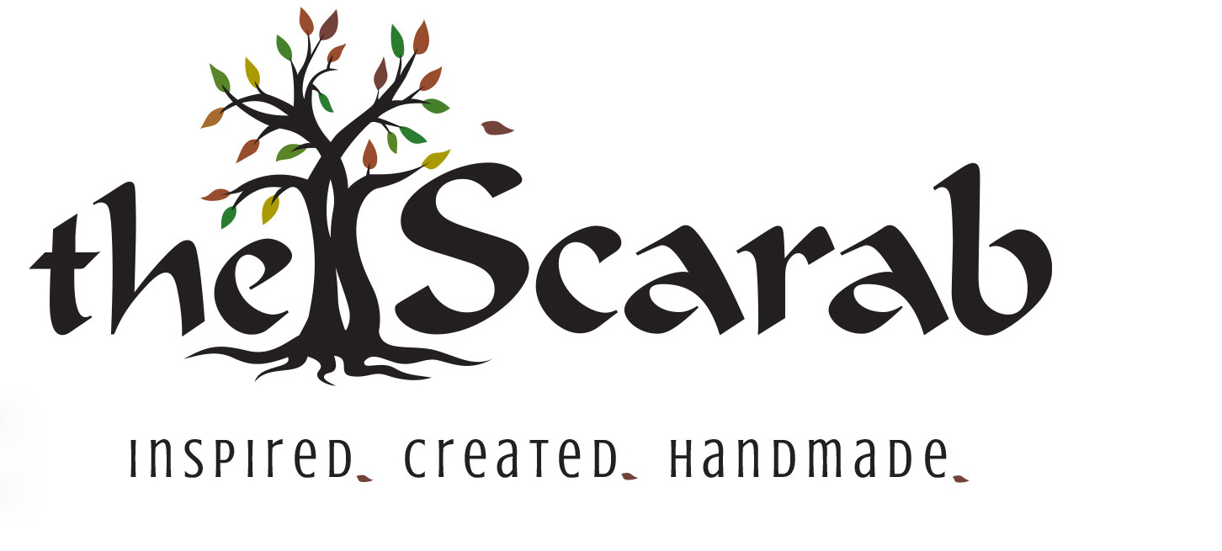

Photography Release Request

This signature request is for acknowledgement and permission to be granted to The Scarab, by the interior designer and the property owner, to photograph the room settings where area rugs are placed in order to promote the creative work of the interior designer.

The photos will be used on The Scarab’s website and social media to promote the designer’s creative work.

I, ______________________ the property owner, by signing below, hereby consent and give permission for The Scarab to photograph and utilize the interior images of design work taken inside my property. My name and address will not be associated with these images anywhere in print or online unless otherwise expressly given.

I, ______________________ the interior designer, by signing below, hereby consent and give permission for The Scarab to photograph and utilize the interior images of my design work taken inside my client’s property identified above.

Date: Date:

________________________ _________________________
Signed, Property Owner Signed, Interior Designer

